|  |  |  |  |  |
| --- | --- | --- | --- | --- |
|  | Bansilal Ramnath Agarwal Charitable Trust's  Vishwakarma Institute of Information  Technology    **Department of**  **Artificial Intelligence and Data Science** | | | |
| Name: Siddhesh Dilip Khairnar | | | | |
| Class: TY | Division: B | | | Roll No: 372028 |
| Semester: V | | Academic Year: 2023-2024 | | |
| Subject Name & Code: Image Processing: ADUA31205(B) | | | | |
| Title of Assignment: Perform linear and non-linear noise smoothing for a noisy image. | | | | |
| Date of Performance: 15-08-2023 | | | Date of Submission: 22-08-2023 | |

**ASSIGNMENT NO. 2**

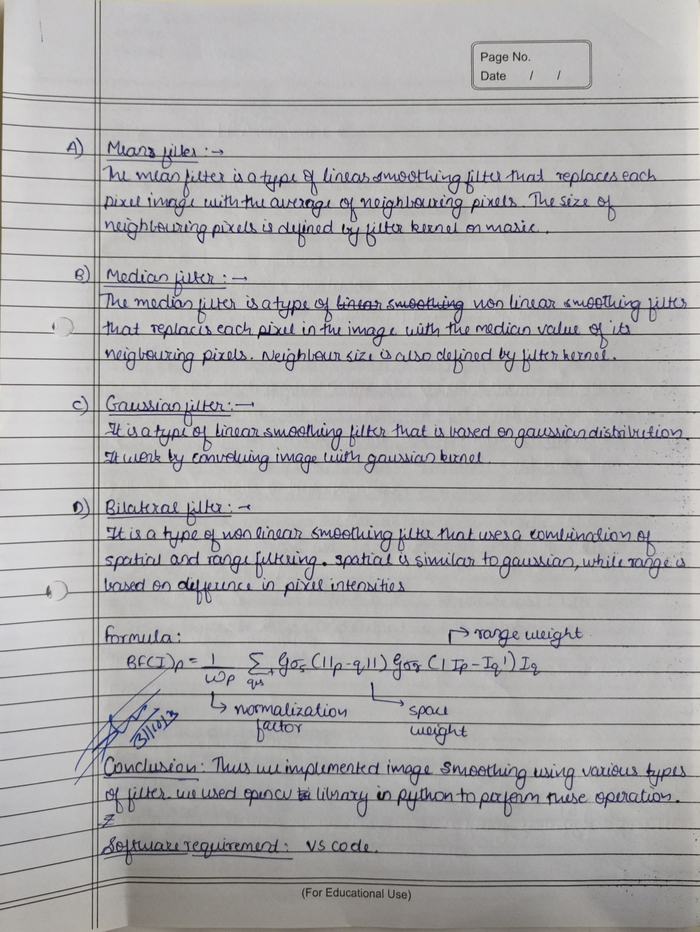

Program Code:

|  |
| --- |
| import cv2    img = cv2.imread("D:\MY FILES\COLLEGE MATERIAL\ASSIGNMENTS\images.jpg") cv2.imshow("Noisy Image",img)    # Linear Smoothing    avg_blur = cv2.blur(img,(5,5))  cv2.imshow('Average Blurring',avg_blur)    gaussian_blur = cv2.GaussianBlur(img,(7,7),0) cv2.imshow('Gaussian Blurring',gaussian_blur)    # Non-linear smoothing    median_blur = cv2.medianBlur(img,5) cv2.imshow('Median Blurring',median_blur)    bilateral_blur = cv2.bilateralFilter(img,9,60,15) cv2.imshow('Bilateral Blurring',bilateral_blur)    cv2.waitKey(0) |

Output:

